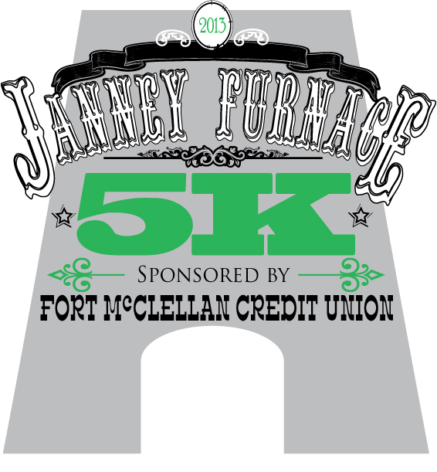

  October 4, 2014, 8:00 AM

Entry Fee-$18.00
before September 26 (less $2 Discount to ARC/GRC members)

Race Day Registrations $22.00
Race Day registration will be between 6:30 AM & 7:30 AM at Janney Furnace Museum 145 Janney Road, Ohatchee, AL 36271. Please pre-register by September 26 to guarantee a long sleeve tech shirt. On race day, shirts available while supply lasts.

Awards
Top three male and female finishers will receive an overall award. Awards will be given to the top three winners in each age category, male and female.

Age Groups
14 & under 20-24 30-34 40-44 50-54 60-64
15-19 25-29 35-39 45-49 55-59 65-69 70 & over

For more information: Kyle Medders 256-282-1460
Dennis Dunn 256- 310-0830
The Cause Proceeds goes to benefit
Friends of Janney Furnace and the Anniston
Lions Local Sight Program.

Course- USATF Certified, fast course
through past historic Janney Furnace and
through downtown Ohatchee.

Start-Run starts at 8:00 AM in front of the
Historic Janney Furnace at 145 Janney Road in Ohatchee, AL 36271 Award Ceremony to follow race.

About Janney Furnace-
Janney Furnace was built by Alfred A. Janney in 1863 & 1864 to produce pig iron during the Civil War. Janney Furnace Park is now part of the Calhoun County Park System and is open to the public daily from 8:00 am to dusk.
Food, fun, door prizes, awards, visit Janney Furnace Confederate and Native American Museum - bring the entire family!

Entry Form
Advance entry before September 26: Mail coupon & $18 5K/ $15 ARC members. Make check payable to: Anniston Lions Club
Mail To: Janney Furnace 5K
Anniston Lions Club
P.O. Box 344
Anniston, AL 36202
(Please Print)
Male Female

Name: Birthdate Phone

Address: E-mail
Shirts Size: Circle One (Limit 1st 125)
City/State/Zip (S) (M) (L) (XL) (XXL)

Note: Entry must be signed and dated below. Release Form
I know that running is a potentially hazardous activity. I should not enter and run unless I am medically able and properly trained. I agree to abide by any decision of a race official relative to my ability to safely complete the run. I assume all risks associated with running or walking in this event including, but not limited to; falls, contact with other participants, the effects of the weather, including high heat and/or humidity, traffic and the conditions of the road, all such risks being known and appreciated by me. Having read this waiver and knowing these facts and in consideration of your accepting my entry, I, for myself and anyone entitled to act on my behalf, waive and release the Calhoun County Commission, the Friends of Janney Furnace, Fort McClellan Credit Union, Anniston Lions Club, the International Association of Lions Clubs, all race sponsors, their representatives, landowners and successors of this event from all claims or liabilities of any kind arising out of my participation in this event.. Applicant hereby agrees to execute a liability waiver in favor of the Owners of the property where the race is scheduled to take place, prior to being allowed to participate in the race. I grant permission to all of the fore-going to use any photographs, motion pictures, recordings or any other record of this event for any legitimate purpose.

Signature Date

Parent’s Signature (if under 18)

